**Capstone Project Documentation: Credit Assist: Note Preparation Tool**

**Overview**

This tool helps prepare draft credit notes for corporate loans by synthesizing financial data, customer information, and loan history. It leverages AI models to analyze customer financials and generate risk scores, along with creating a detailed narrative summarizing risk factors associated with loan applications.

**Key Features**

* **Data Synthesis**: Combines financial data, customer information, and loan history.
* **Risk Scoring**: Uses AI models to generate risk scores based on financial analysis.
* **Risk Narrative Creation**: Develops a detailed narrative highlighting risk factors.
* **User Validation**: Provides interfaces for validation and feedback on credit notes.

**Architecture**

**Data Layer / Data Lake**

* **ERP Systems**: Source of structured financial and customer data.
* **Credit History and Financial Records**: Stored for analysis and risk assessment.

**Data Processing**

* **Information Extraction**: Collects data from various sources, including OCR for unstructured data.
* **Python Frameworks**: Used for data preprocessing and storage in vector databases.

**AI Components**

* **Risk Narrative Development**: Combines rule-based, ML-based, and LLM-driven risk assignments.
* **Credit Note Generation**: Templates and final notes are automatically prepared.

**Implementation Steps**

1. **Data Collection**: Gather data from ERP systems and financial records.
2. **Data Preprocessing**: Extract and clean data for analysis.
3. **Risk Scoring**: Apply AI models to compute risk scores.
4. **Narrative Creation**: Develop risk narratives using AI reasoning.
5. **Credit Note Generation**: Create draft credit notes with validation steps.

**Tools and Technologies**

* **Python**: For data processing and model implementation.
* **Machine Learning and LLMs**: For risk scoring and narrative development.
* **UI/UX Tools**: For user validation and feedback interfaces.

**Evaluation Metrics**

* **Risk Score Accuracy**: Measure the precision of generated risk scores.
* **Narrative Quality**: Assess the clarity and comprehensiveness of risk narratives.
* **User Feedback**: Evaluate user satisfaction with the validation process.

**Tentative Data Schema for Credit Assist: Note Preparation Tool Project**

This schema serves as a guideline and can be adjusted based on specific project needs.

1. **Customer Table**
   * **customer_id**: Unique identifier for each customer (Primary Key)
   * **name**: Customer’s name
   * **financial_data**: Summary of financial information
   * **credit_history**: Record of past credit transactions
2. **Loan Application Table**
   * **application_id**: Unique identifier for each loan application (Primary Key)
   * **customer_id**: Associated customer identifier (Foreign Key)
   * **loan_amount**: Amount requested in the loan
   * **application_date**: Date of the loan application
3. **Risk Score Table**
   * **risk_id**: Unique identifier for each risk assessment (Primary Key)
   * **application_id**: Associated loan application identifier (Foreign Key)
   * **risk_score**: Calculated risk score
   * **risk_factors**: Key factors contributing to the risk score
4. **Credit Note Table**
   * **note_id**: Unique identifier for each credit note (Primary Key)
   * **application_id**: Associated loan application identifier (Foreign Key)
   * **note_content**: Text content of the credit note
   * **validation_status**: Current status of the note validation
5. **Feedback Table**
   * **feedback_id**: Unique identifier for each feedback entry (Primary Key)
   * **note_id**: Associated credit note identifier (Foreign Key)
   * **user_feedback**: Text of user feedback
   * **timestamp**: Date and time of the feedback submission

**Note**: This data schema is tentative and can be adapted to fit different requirements or data sources. Graduates are encouraged to modify it as needed to address specific challenges in the project.

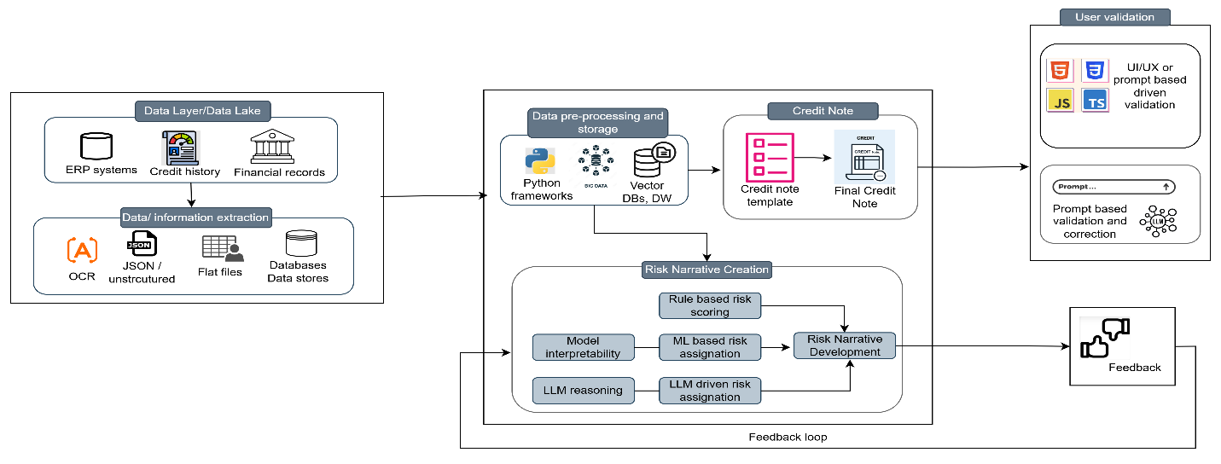

*The shared architecture flow diagram is intended to serve as a reference for building the solution. It can be adjusted or accommodated as needed, and some elements may require further exploration and adaptation. The instructions in the capstone projects act as guidance to support your development process.*